

Scheduling V. 5.3

Primary Care Management Module (PCMM)

Transmission of Provider Workload to AAC

(SD*5.3*272)

User Manual

April 2003

Table of Contents

1. Background 3
1.1 Overview of the Primary Care Management Module 3
1.2 Acronyms 3
1.3 PCMM Direct Care FTEE (404.52, .09) 4
2. Introduction and Patch Description 5
2.1 Patch SD*5.3*272 5
2.2 Trigger Events 5
3. ADPAC Instructions 7
3.1 User Information 7
3.2 Instructions 7
3.3 Workload Data Transmission Validation 10
3.4 Error Processing 13
4. Troubleshooting Tips 18

Background

1.1 Overview of the Primary Care Management Module

The Primary Care Management Module (PCMM) was developed to assist VA facilities in implementing primary care. PCMM supports both primary care and non-primary care teams. Teams are groups of staff members organized for a certain purpose. The software allows you to setup and define a team, assign positions to the team, assign staff to the positions, assign patients to the team, assign patients to practitioners, and reassign patients from one team to another team.

Tools are provided with the software to facilitate the startup process. These tools use the site's data (where available) to automate the following tasks: identify patients to be assigned to primary care; assign patients to teams; and assign patients to practitioners via team positions.

PCMM provides control over the transmission of MailMan messages to team positions. MailMan messages are categorized into patient death, inpatient activity, consult activity, and team activity. For each category, a user can elect to have a position get messages for all patients on a team; to have messages sent only on patients associated with that team position, or to not send messages at all.

Every patient must be assigned a primary care provider (PCP). A PCP can be a medical doctor (MD), doctor of osteopathy (DO), nurse practitioner, or physician assistant. Residents may not be considered as a PCP in this system.

The PCMM “business rules” provide information on how some of the PCMM fields are handled for team and team positions. These rules are not intended to be all encompassing, but to allow basic checking within the system to ensure data integrity. These rules can be found in VHA Directive 99-065:
http://vaww.va.gov/publ/direc/health/direct/199065.pdf

1.2 Acronyms

AAC- Austin Automation Center
Direct PC FTEE- Direct Primary Care Full Time Employee Equivalent
DO- Doctor of Osteopathy
HL7- Health Level 7
MD- Medical Doctor
NP- Nurse Practitioner
PA- Physician Assistant
PCDPC- Primary Care Direct Patient Care
PCMM- Primary Care Management Module
PCP- Primary Care Provider
VA- Department of Veterans Affairs
VHA- Veterans Health Administration

Note: Field names, listed in the text, will be followed by their corresponding file and field number. (Ex. PCMM Direct Care FTEE (404.52, .09)

1.3 PCMM Direct Care FTEE (404.52, .09)

PCMM is used by the Veterans Health Administration (VHA) to measure its capacity for patient care. A recent VHA directive expresses a pressing need to capture consistent and accurate data on its capacity to provide primary care to patients. Recent PCMM enhancements (SD*5.3*264 and SD*5.3*277) were developed to meet this need.

It has been determined that the most reliable way to collect data is for each facility to document direct patient care time and non-patient care time in the same manner. The (VHA) Directive requires the entry and transmission of two key fields of information related to Primary Care Provider resources. The first field, Primary Care Direct Patient Care (PCDPC), is the amount of time each PCP spends providing direct patient care to outpatients. PCDPC is defined as the time to prepare for, provide for, and follow-up on the clinical care needs of outpatient, primary care patients. This data is captured in the “Direct PC FTEE” (Primary Care Full Time Employee Equivalent) field. “Direct PC FTEE” is a field in PCMM GUI version 1.2.3.1 used to indicate the percentage of time PCP’s dedicate to direct patient care (not available in VISTA, however data can only be accessed through Fileman in VistA.) For more information on how PC FTEE is computed see the PCMM Enhancements for Direct Primary Care (SD*5.3*277) User Guide:
http://www.va.gov/vdl/VistA_Lib/Clinical/Pri_Care_Mgmnt_Module_(PCMM)/SD_53_277.UM-Final.doc

The second field is the expected maximum panel size that has been established for each PCP’s panel. It represents the maximum number of patients each PCP is expected to provide care for their panel. The maximum expected panel size is set locally based on a host of factors known to affect panel size. This data is captured in the MAX NUMBER OF PATIENTS field (404.57, .08.)

Introduction and Patch Description

2.1 Patch SD*5.3*272

The data captured with the “Direct PC FTEE” field must be transmitted from local sites to a database at the Austin Automation Center (AAC). This action allows the VHA to measure the capacity for primary care. This patch will enable sites to transmit provider workload data to AAC. The transmission is performed using the abstract message approach and encoding rules specified by HL7 standards.

HL7 is used for communicating data in the FTEE field (404.52, .09), and the MAX NUMBER OF PATIENTS field (404.57, .08). The formats of these messages conform to Version 2.4 HL7 Interface Standards where applicable. The data sent in the HL7 messages is limited to the information that can be processed by the AAC. A nightly background job will send HL7 messages for each change in direct patient care FTEE and Position Maximum Workload. HL7 V. 1.6 of the VA MailMan lower level protocol (LLP) is used. This version of the VA MailMan LLP differs from HL7 V. 1.5 in that a blank line is placed between each segment in the message [denoting a carriage return]. See section 4 (Troubleshooting Tips) for more information on reading HL7 messages.

Note: There is no new version of PCMM GUI associated with this patch.

2.2 Trigger Events

The PCMM provider workload transmission is activated, an HL7 event is triggered, and an HL7 message is created when the following trigger events occur (multiple events will trigger multiple messages. All trigger events cause messages to be placed in a nightly queue for transmission to the AAC):

Trigger Event | PCMM HL7 Provider Workload ZFT Segment Element Update
FTEE Entered on Practitioner Position Assignment | Direct Patient Care FTEE = current value
FTEE edited on Practitioner Position Assignment | Direct Patient Care FTEE = current value
Practitioner Inactivated from Position | Direct Patient Care FTEE = 0; Maximum Workload = 0
Practitioner Activated to the Position but not allowed to provide primary care | Direct Patient Care FTEE = 0; Maximum Workload = 0
Changes MAX Number of Patients in Panel | Maximum Workload = current value
Position Changed to Not Allow to Be Primary Care | Direct Patient Care FTEE = 0; Maximum Workload = 0
Position Changed to Allow to Be Primary Care | Direct Patient Care FTEE = current value; Maximum Workload = current value
Primary Care Provider with multiple (more than one) positions assigned | Direct Patient Care FTEE = cumulative current value for all active positions on all teams for given provider; Maximum FTEE cannot be greater than 1.0; Maximum Workload = cumulative current value for all active positions on all teams for given provider
Provider Inactivation due on a future date. | Direct Patient Care FTEE = 0; Maximum Workload = 0 on the date provider scheduled to become inactive

3. ADPAC Instructions

3.1 User Information

Patch SD*5.3*272 will provide for the transmission of provider workload to the AAC.
Entering and editing Primary Care FTEE data and other changes (see trigger events) in PCMM will trigger HL7 events. These messages are transmitted at the same time current PCMM HL7 messages are transmitted to AAC. This is usually a nightly scheduled task. A maximum of 2500 messages can be sent at one time.

Note: There are two types of HL7 messages sent to AAC; PCMM-Patient messages (contain the practitioner/patient assignment for PCP), and the new PCMM-Provider workload messages created with Patch SD*5.3*272.

What is HL7?

Health Level 7 is an ANSI standard that defines the fundamental aspects of the electronic exchange of health care data.

What is an HL7 message?

HL 7 messages are constructed from a defined sequence of segments.

- An HL7 message is a group of logically related records (segments.)
- Messages are classified by a three-character code (message type.)
- Segments are the building blocks for HL7 communications
- Segments are reusable in message definitions, but fields are typically tied to a single segment.
- Because segments have varying length and can repeat, messages have widely ranging lengths.
For more information on HL 7 see http://vista.med.va.gov/hl7/train/hl7_intro.pdf

3.2 Instructions

How is workload data transmitted to AAC?

PCP FTEE changes, panel size changes, and provider position assignment changes trigger HL 7 events, these events create HL7 messages. The messages are put into a queue until the next time a site sends their HL7 messages to the AAC. The time or frequency for sites sending HL 7 messages is usually nightly but may be decided locally.

Note: FTEE levels exceeding 1.0 will generate a 702M error that can be seen in
the PCMM Transmission Error Processing option. When the FTEE level is
corrected a new message will be transmitted.

The following fields are also transmitted to AAC:

  - Provider’s name
  - Provider’s suffix
  - PCP’s FTEE
  - Provider’s Panel Size
  - Institution
  - Institution Numbers (five digit)

To trigger a workload data transmission

- Log on to PCMM GUI.

- Click on “Team” menu item.

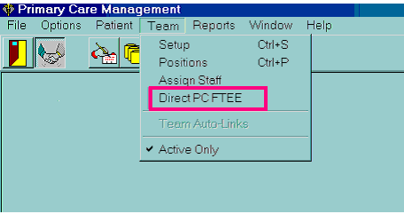

3. If the user performs one of the above mentioned trigger events (section 2.2) an HL 7 message will be created. Below are several examples of screens for which trigger events may be launched. Data transmissions can only be validated in VistA. Examples will be given in section 3.3 (Workload Transmission Data Validation.)

Direct PC FTEE

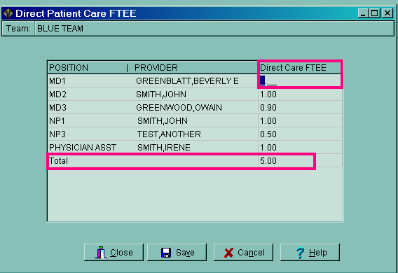

Staff Inactivate
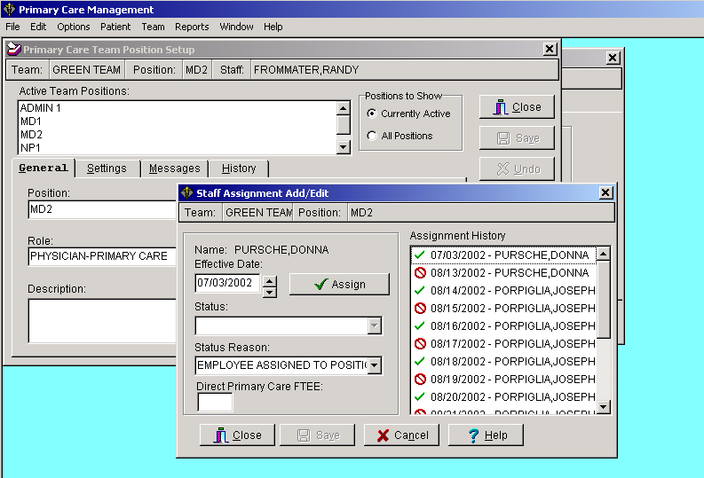

Changing Panel Size

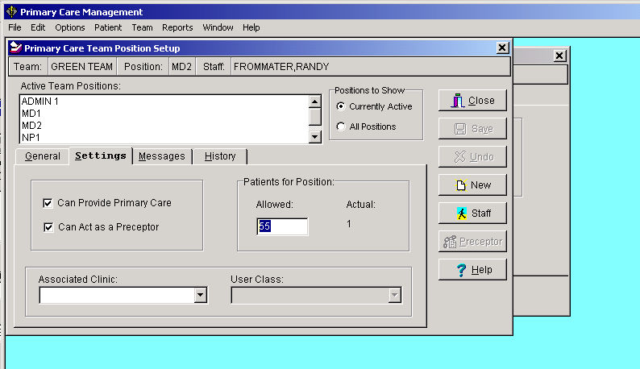

3.3 Workload Data Transmission Validation

To monitor workload data transmissions to the AAC:

-Users can check the PCMM Work HL7 Event File to see if changes in provider workload triggered events.
-Receive messages from the PCMM FTEE Workload Mail Group, who receive Mailman messages listing triggered events
- Or create one of the following reports; a Fileman report for the HL7 Event File, PCMM “Direct PC FTEE”, or Maximum Panel Size report. Below are examples of these reports. The reports provide a listing of the data a site has in VISTA that can be compared with what has been sent to the AAC.

HL7 Event File

Select VA FileMan Option: Inquire to File Entries

OUTPUT FROM WHAT FILE: PCMM HL7 EVENT (15295 entries)
Select PCMM HL7 EVENT DATE/TIME OF EVENT: ?
Answer with PCMM HL7 EVENT DATE/TIME OF EVENT, or PATIENT
Do you want the entire 15295-Entry PCMM HL7 EVENT List? y (Yes)
Choose from:
OCT 14, 1999@06:31:38 1;SCTM(404.53,
OCT 14, 1999@06:31:38 2;SCTM(404.53,
OCT 14, 1999@06:31:38 3;SCTM(404.53,43,
^
Select PCMM HL7 EVENT DATE/TIME OF EVENT: 10-29-99 OCT 29, 1999
1 10-29-1999@11:41:15 DOE, JOHN 14687 ;SCPT(404.43,
2 10-29-1999@15:36:10 SMITH, JOHN 11274 ;SCPT(404.43,

CHOOSE 1-2:1 10-29-1999@11:41:15 DOE, JOHN 14687 ;SCPT(404.43,
ANOTHER ONE:
STANDARD CAPTIONED OUTPUT? Yes// (Yes)
Include COMPUTED fields: (N/Y/R/B): NO// - No record number (IEN), no Computed Fields

Note: This sample trigger event is associated with the original PCMM HL7 messaging and not PCMM Workload HL7 messaging.

DATE/TIME OF EVENT: MAR 31, 2003@10:26:50
TRANSMISSION REQUIRED: NO TEAM POSITION: 49
USER: SMITH,JOEL EVENT POINTER: PC TEAM 1 WORKLOAD: WORKLOAD

PCMM “Direct PC FTEE Report” [SC PCMM REPORTS MENU]

The PCMM Direct Primary Care FTEE Report can only be printed from VISTA.

- Enter/select the “PCMM Reports Menu Option.” [SC PCMM REPORTS MENU]
- Enter/select the “PCMM Direct Primary Care FTEE Option.” These options are shown below. The next page shows needed entries once the Direct PC FTEE Report is entered.

Select <SMA> PCMM Reports Option:
[SC PCMM REPORTS MENU]

FTEE PCMM Direct Primary Care FTEE
DPA Detailed Patient Assignments
HAR Historical Assignment Reports ...
INCR PCMM Inconsistency Report
ITP Individual Team Profile
PATA Patient Listing for Team Assignments
PD Practitioner Demographics
PP Practitioner's Patients
SLT Summary Listing of Teams
TML Team Member Listing
TPL Team Patient Listing

- To print the FTEE report for all institutions, accept “FIRST” default by pressing the <enter> key. “FIRST” must always be in CAPS, otherwise a report will not be created.

*Previous selection: INSTITUTION not null

START WITH INSTITUTION: FIRST// <ENTER>

DEVICE: TELNET PORT Right Margin: 80//

- To print for one institution, enter the institution name after the “Start with Institution” prompt.

Note: If the institution name is used at the FIRST and LAST prompts, it must be complete and exactly as it appears in the Institution file (file #4), or the report will not contain any data. For example, enter “VAMC ALBANY” not just “ALBANY.” Entering “ZZ” to the institution name at the “last” prompt can also produce the report.
Example:

START WITH INSTITUTION: FIRST// VAMC ALBANY
LAST// VAMC ALBANYZZ

DEVICE: TELNET PORT Right Margin: 80//
MARGIN WIDTH IS NORMALLY AT LEAST 132.ARE YOU SURE? No//yES

Direct PC FTEE SEP 11,2002 10:37 PAGE 1

PRACTITIONER TEAM Direct PC
POSITION CLINIC FTEE
-----------------------------------------------------------------

INSTITUTION: ALBANY VAMC

TEST, JAMES RED TEAM 1.0
MD1
SUBTOTAL 1.0

SMITH, LUTHER RED TEAM 0.8
PA1

SUBTOTAL 0.8

SMITH, NANCY RED TEAM 0.3
NP2 GREEN TEAM 0.7
SUBTOTAL 1.0

TOTAL 2.8

Maximum Panel Size Report

Create Fileman report as follows:

Select: VA FILEMAN
Select OPTION: PRINT FILE ENTRIES
OUTPUT FROM WHAT FILE: TEAM POSITION//
SORT BY: POSITION// .04 POSSIBLE PRIMARY PRACTITIONER?
START WITH POSSIBLE PRIMARY PRACTITIONER?: FIRST// 1 YES
GO TO POSSIBLE PRIMARY PRACTITIONER?: LAST// 1 YES
WITHIN POSSIBLE PRIMARY PRACTITIONER?, SORT BY: .01 POSITION
START WITH POSITION: FIRST//
WITHIN POSITION, SORT BY:
FIRST PRINT FIELD: .01 POSITION
THEN PRINT FIELD: MAX NUMBER OF PATIENTS
THEN PRINT FIELD:
Heading (S/C): TEAM POSITION LIST//
START AT PAGE: 1//

3.4 Error Processing

Error processing is also an important part of assuring that workload data will be transmitted to AAC. This is primarily done through the use of the PCMM Reject Transmission Menu and the PCMM Reports.

PCMM Transmission Error Code Report (SCMC PCMM ERR CODE REPORT)- This report will print a list of the error codes and descriptions for entries in the PCMM HL7 ERROR CODE file.

Example:

SCMC PCMM REJECT TRANS MENU PCMM Reject Transmission Menu

ECR PCMM Transmission Error Code Report
EP PCMM Transmission Error Processing
ER PCMM Transmission Error Report

Select PCMM Reject Transmission Menu Option: ecr PCMM Transmission Error Code Report

DEVICE: HOME// TELNET PORT Right Margin: 80//
PCMM Transmission Error Code Report MAR 20,2003 14:50 PAGE 1

ERROR CODE FIELD DESCRIPTION

000M No errors.
001M EVN segment missing (Contact IRM for assistance).

002M PID segment missing (Contact IRM for assistance).
003M ZPC segment missing (Contact IRM for assistance).
005M Invalid segment name (Contact IRM for assistance).
006M ORG segment missing
007M STF Segment Missing
008M ZPT Segment Missing
104M Event Date/Time Event Date is missing or out of range.
106M Event Date/Time Event Time is invalid or missing.
110M Message Control ID Message Control ID missing(Contact IRM for assistance).
113M Event Type Event Type is not 'A08' (Contact
IRM for assistance).
114M 2 EVN must be B02
200M Patient Name Patient Name is missing or
invalid.
210M Patient ID Patient ID is missing or not
numeric.
220M Date of Birth Date of Birth is missing.
221M Date of Birth Invalid year or year greater than the processing year.
223M Date of Birth Invalid Date of Birth.
224M Date of Birth Date of Birth greater than
processing date.
230M Sex Sex code is invalid or missing.
240M Race Invalid Race code.
250M Marital Status Invalid Marital Status code.
260M State Invalid state code.
261M County Invalid County code.
262M Address Line 1 Address Line 1 is all numeric.
263M Address Line 2 Address Line 2 is all numeric.
264M City City contains all numbers.
270M Religion Invalid Religion code.
280M Zip Code Zip Code not numeric.
290M SSN SSN is missing, or not numeric,
or is equal to zeros.
291M SSN Pseudo SSN is not 'P' or blank.
300M Provider Assignment ID Provider Assignment ID is
invalid.
310M Provider ID Non-numeric ID and/or invalid
entry.
320M Date Provider Assigned Date Provider Assigned is an I invalid date.

330M Date Provider Unassigned Date Provider Unassigned is an
invalid date (if date is
present).

340M Provider Type Code Provider Type Code is not 'PCP
or 'AP'.
350M Provider Person Class Provider Person Class (seq 6 comp
1) is invalid.
360M Provider Person Class Provider Person Class (seq 6 comp
3) not 'VA8932.1'.
370M Provider SSN Required. SSN not numeric or all zeros.
502M 2 Invalid Staff Code
602M 2 Invalid Organization Unit Code
608M 8 Invalid Area of Specialization
702M 2 DIRECT PATIENT CARE FTEE INVALID
703M 3 MAXIMUM WORKLOAD INVALID
801M 1 Missing Field Separator
802M 2 Missing encoding character
809M 9 Missing Message Type
810M 10 Missing Message control ID
811M 11 Missing processing ID
812M 12 Missing version ID

CS Change Sort By Criteria PL Print List
MC Mark Error as Checked/Corrected MN Mark Error as New/Uncheck
SP (Select Record(s) for Retransmit) DP(Deselect Record(s)for retransmit)
SA (Select All for Retransmit) DA(Deselect All for Retransmit)
CE Change Error Processing Status CD Change Date Range
CS Change Sort By Criteria PL Print List

PCMM Transmission Error Processing (SCMC PCMM TRANS ERROR PROC)- This option permits users to review transmission errors logged in the PCMM HL7 TRANSMISSION LOG file. The status of an error may be changed with this option.

Example:

PCMM Transmission Errors Mar 20, 2003@14:51:38 Page: 1 of 5
Sort By: Data Error Received Date Range: (None) List All Errors
Error Processing Status: New/Checked * - Marked for re-transmit

Patient Name PATID Date Rec'd Provider Type EP Stat

1 Unknown 01/16/03 N/A N/A New
Error: 703M - MAXIMUM WORKLOAD INVALID

2 Workload 02/03/03 Doe, John PC Checked
Error: 602M - Invalid Organization Unit Code

3 Workload 02/03/03 Doe, Jane PC Checked
Error: 608M - Invalid Area of Specialization

4 Workload 02/03/03 Test, Mike PC Checked
Error: 602M - Invalid Organization Unit Code

5 Workload 02/03/03 Test,Barb PC Checked
Error: 602M - Invalid Organization Unit Code

+ Enter ?? for more actions >>>
SP (Select Record(s) for Retransmit) DP(Deselect Record(s) for Retransmit)
SA (Select All for Retransmit) DA(Deselect All for Retransmit)
CE Change Error Processing Status CD Change Date Range
CS Change Sort By Criteria PL Print List

PCMM Transmission Error Report (SCMC PCMM TRANS ERROR REPORT)- This report prints a list of patients for which HL7 transmission errors were received from the Austin Automation Center (AAC). The user will have the ability to print all transmission errors or may print errors for a selected date range. Users will also have the ability to sort the error list by patient name, date/time error received, or provider name.

Example:

Select PCMM Reject Transmission Menu Option: er PCMM Transmission Error Report

Select one of the following:

A All Errors
D Date Range

Select all errors or a date range: All Errors

Select one of the following:

N Patient Name
D Date Error Received
P Provider

Select sort criteria for listing PCMM Transmission Errors: Data Error Received

Select one of the following:

1 New
2 Checked
3 Both

Select Error Processing Status: b Both
DEVICE: HOME// TELNET TERMINAL

See report on the following page.

PCMM Transmission Error Report Run Date: Mar 10, 2003 6:00:31 pm Page 1

Sort By: Data Error Received Date Range: (None) List All Errors
Error Processing Status: New/Checked *-Marked for re-transmit

Patient Name PATID Date Rec Provider Type EP Status

Test, Mike 01/16/03 N/A N/A New
Error: 703M-MAXIMUM WORKLOAD INVALID

Test, Car 02/03/03 N/A N/A Checked
Error: 602M-Invalid Organization Unit Code

Test, Don 02/03/03 N/A N/A Checked
Error: 608M-Invalid Area of Specialization

Test, Ed 02/03/03 N/A N/A Checked
Error: 602M-Invalid Organization Unit Code

Test, Lou 02/03/03 N/A N/A Checked
Error: 602M-Invalid Organization Unit Code

Test, Abe 02/03/03 N/A N/A Checked
Error: 602M-Invalid Organization Unit Code

Test, Jay 02/03/03 N/A N/A Checked

Enter RETURN to continue or '^' to exit:

4. Troubleshooting Tips

Consider these items when determining if PCMM provider workload data is being transmitted to AAC:

- Required Patches- Installation:
  - Verify that the site installed PCMM Baseline Seeding patch SD*5.3*212 and INCORRECT PRECEPTOR ASSIGNMENT HISTORY patch SD*5.3*224.
  - Ensure that the PCMM Baseline Seeding [SCMC PCMM BASELINE SEEDING] option from patch SD*5.3*212 was run. This may be accomplished by performing a FileMan inquiry on the entry in the PCMM PARAMETER (#404.44) file and determining if the BASELINE RUN DATE (#17) field has been populated.
  - If the BASELINE RUN DATE (#17) field does not contain a date indicating that the PCMM Baseline Seeding [SCMC PCMM BASELINE SEEDING] option had run, please log a NOIS or contact the National Help Desk at 1-888-596-HELP (4357) for assistance.
  - SD*5.3*264
  - SD*5.3*278
  - XM*DBA*251

- Local PCMM Reports:
- PCMM Inconsistency Report
- PCMM Transmission Error Processing (See example in section 3.2.3 Error Processing)

Note: that data will be held in VISTA and not transmitted to Austin (via HL7 message) until corrections are made to the errors identified in above reports.

- HL7 PCMM links and filers:
It is important to monitor the HL7 PCMM links and filers. If the VISTA system is rebooted or has had an error the links and filers may be shut down and need to be restarted. If the HL7 PCMM links and filers are not running then data is not being transmitted to the AAC.

These are some other items to consider when transmitting and validating workload data.

1. Patient Team Position Assignment Review This option compares all PATIENT TEAM POSITION ASSIGNMENT (#404.43) file entries with the corresponding PATIENT TEAM ASSIGNMENT(#404.42) file entries. This comparison checks to make sure that the position assignment active timeframe is within the team assignment active timeframe. This report lists those position assignments that fall outside the team assignment active timeframe.

The report list discrepancies between team assigned and unassigned date.

Assigned Unassigned
Date Date
-------- ----------
Team Assignment 01/01/1997 10/31/1997
Position Assignment 02/15/1997 <none>

2. EP PCMM Transmission Error Process This option permits users to review transmission errors, logged in the PCMM HL7 TRANSMISSION LOG file that were rejected from the AAC due to demographic errors.

3. INCR PCMM Inconsistency Report Option to print the Inconsistencies that may exist according to the new Business Rules that were established in Phase II of PCMM (Patch # 177).

4. Reading HL7 Messages It is also important to be able to read HL7 messages properly. On the following page is a sample of a HL7 message with its segments identified in parentheses.

Subj: HL7 Msg FEB 13,2003@08:28:20 (Date/time) from XXX VAMROC [#4286149] (Message Number)(Mailman Message)
From: POSTMASTER In 'IN' basket. Page 1 *New*
-------------------------------------------------------------------------------
MSH^~|\&^PCMM^442~XXXXX.MED.VA.GOV(Institution) ~DNS^NPCD- AAC^200^20030212094622-0500^^PMU
~B02^4422234136^P^2.4^^^NE^AL^USA

EVN^B02 (Event Trigger)^20030212094622-0500

STF^^1440~~~USVHA~LR~589GM|~~~USSA~SS^SMITH~MICHAEL~D. (PCP name)

ORG^1^589GM~CHANUTE^^^^^^~

ZFT^1^.85 (Provider FTEE)^600 (Panel Size)

Enter message action (in IN basket): Delete//

Select Option: PCMM HL7 TRANSMISSION [SCMC PCMM HL7 TRANSMIT]
PCMM HL7 Transmission
0 messages sent.

